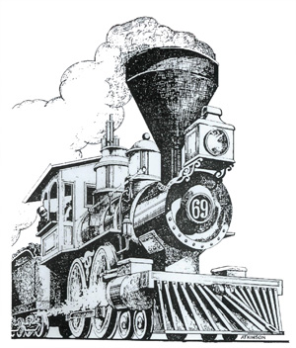Raylrode Daze 2024
5th Annual Golf Tournament
June 15, 2024

Hillcrest Golf Course
Tee Time 9:00 am

Hole Sponsor $100
Beverage Cart Sponsor $250

Cost for Tournament
Three Man’s Captain Choice
• Teams $180 • Players $60 • 2 Mulligans $5 each
Players E-mail Address Phone # Handicap
1.____________________ ______________________ _____________ __________
2.____________________ ______________________ _____________ __________
3._____________________ ______________________ ______________ __________
All Money Raised goes to: 2024 Raylrode Daze Festival
Contact Frank Dickson at Clemsonfd03@gmail.com or 803-347-6874
or Flyn Dickson at 843-830-9962
Sponsorship & Teams can be turned in at Branchville Town Hall
Please make checks out to Branchville Raylrode Daze

